2.5 Lab: Install Python 3 on Your System
1. Proof of Python Install on my Local Host:
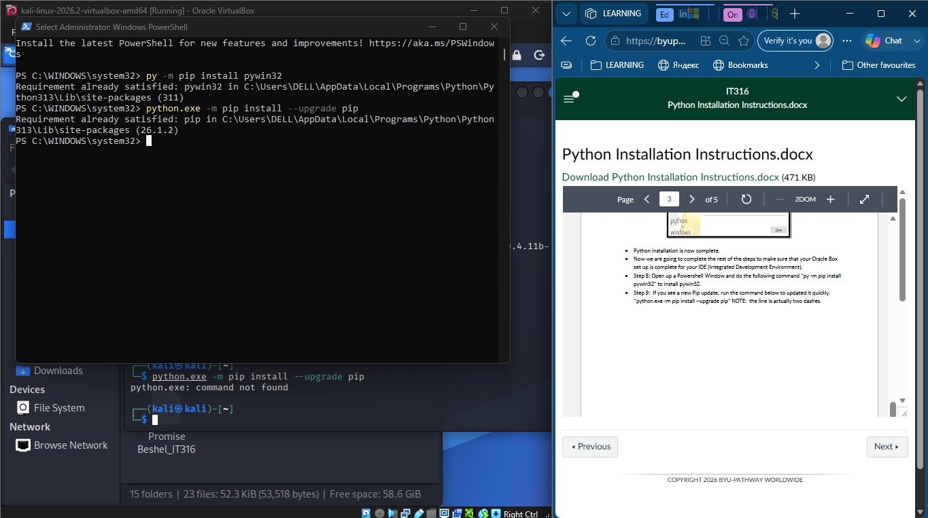
I already had python running prior to this course. The Powershell footage shows that all requirements on my local computer have already been met.

2. Proof of Python Installation on my virtual machine (Kali Linux Instance)
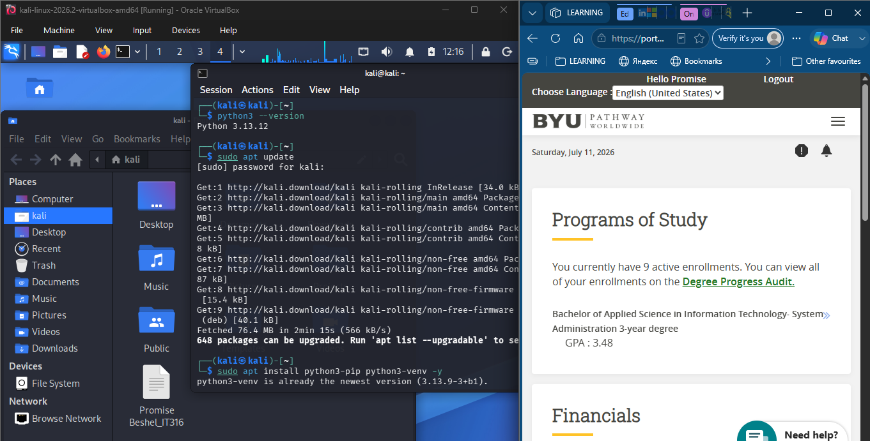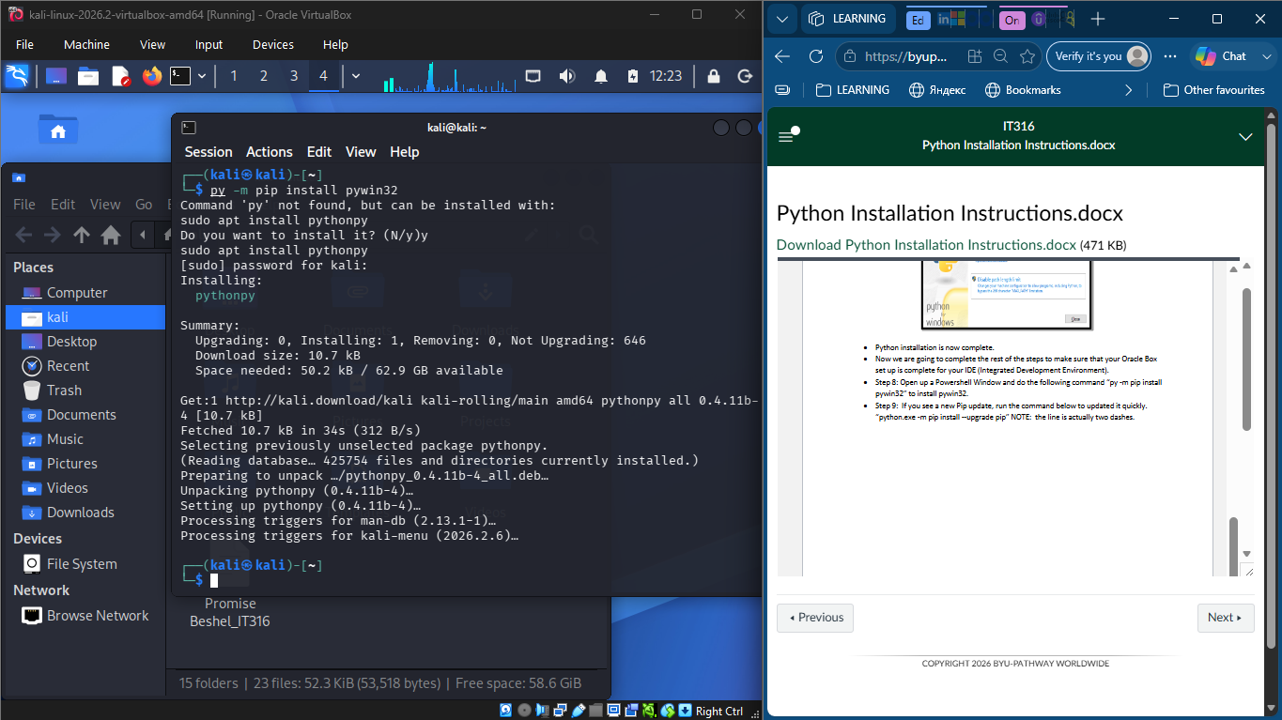

The above screenshots clearly show that python 3 is running smoothly on my Kali Linux VM instance.

